https://www.youtube.com/watch?v=vCJVFnepECc&list=PLUDwpEzHYYLuW9XEvFEJk2kqsk6HqscI4
Session1: Introduction to API Testing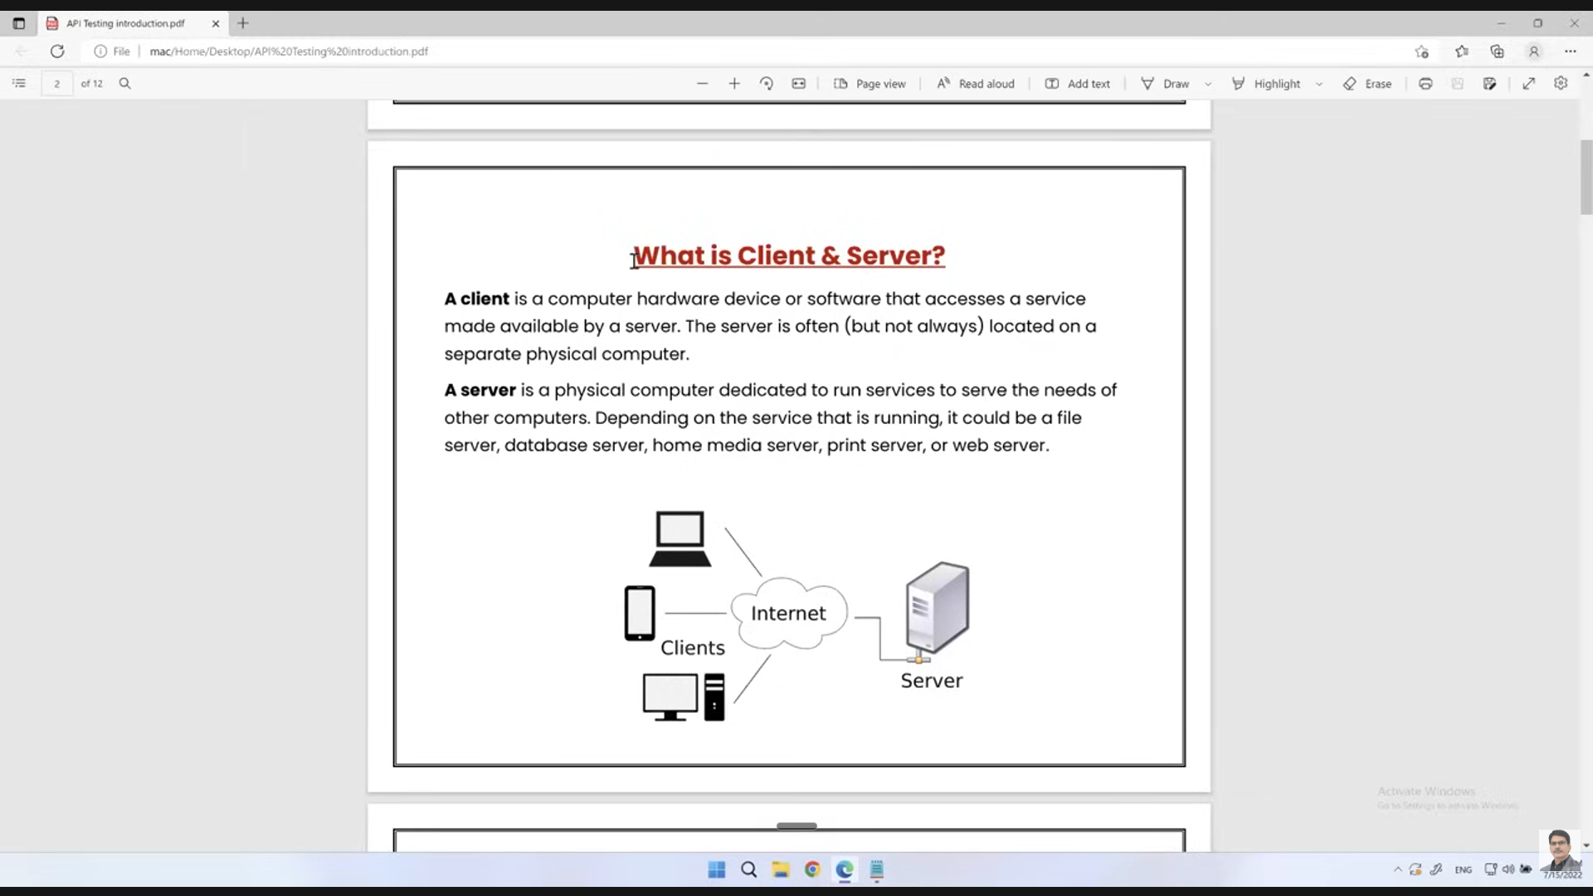
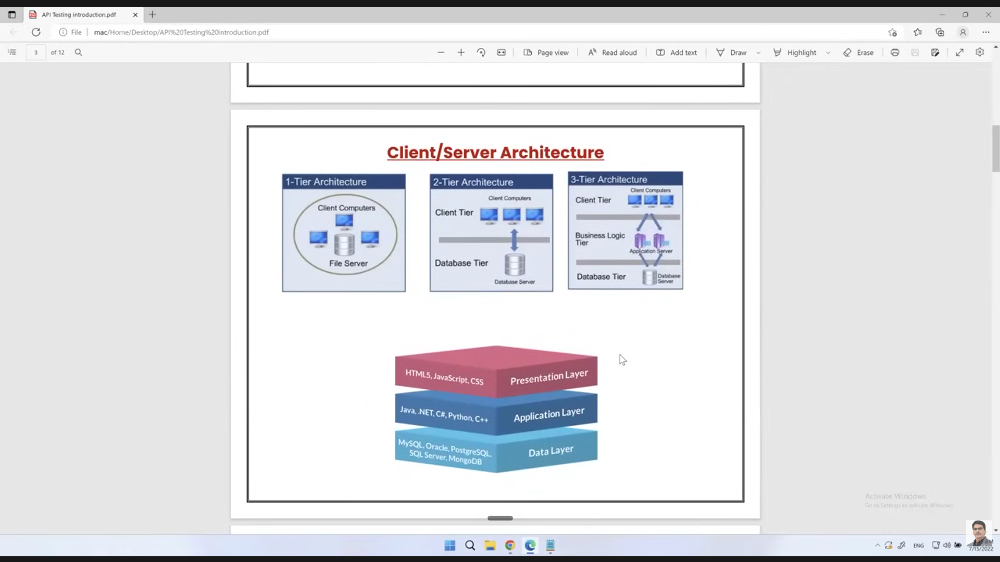
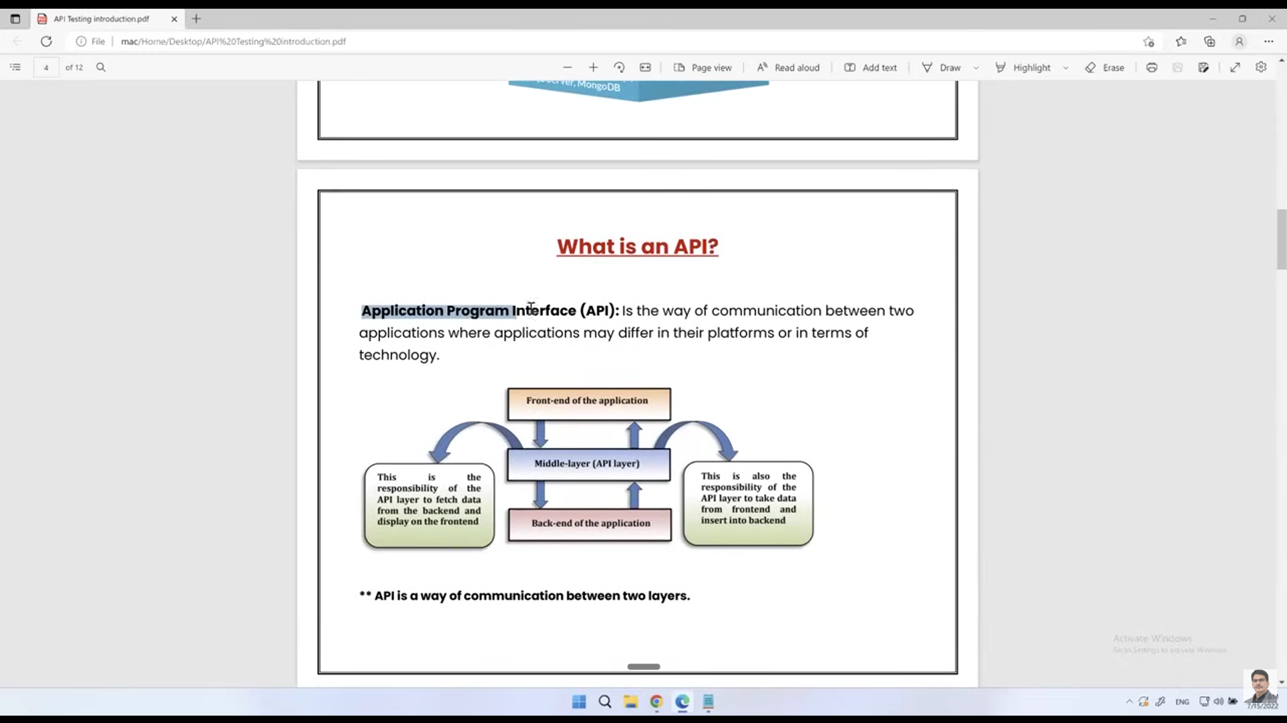
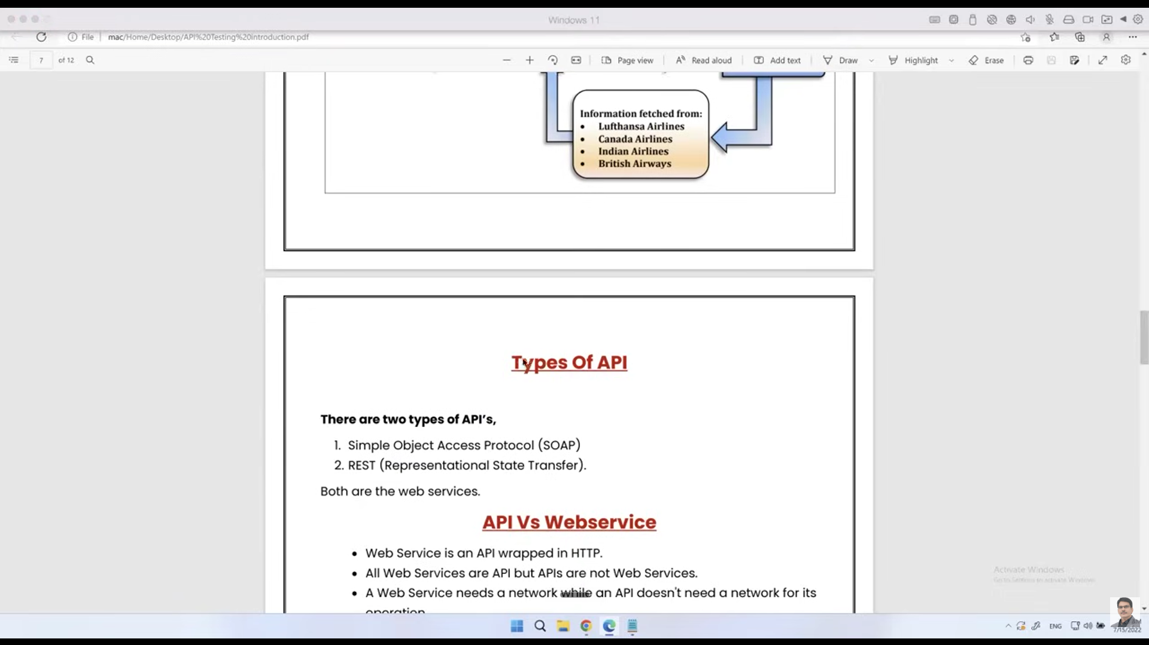
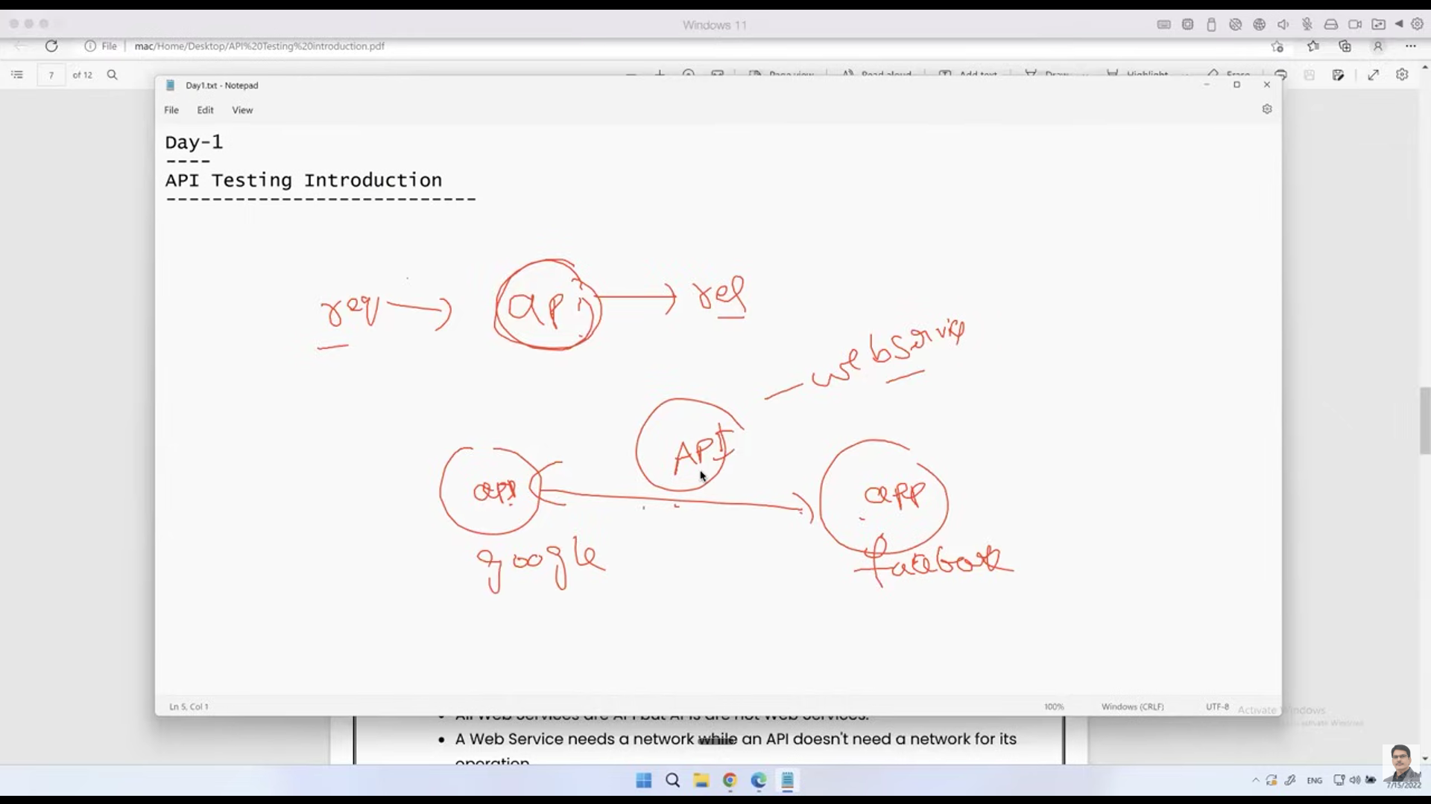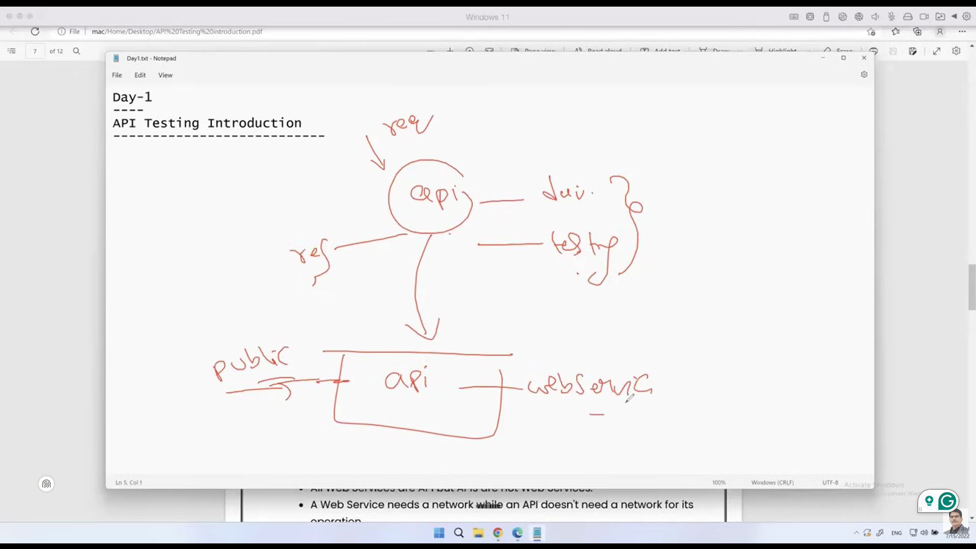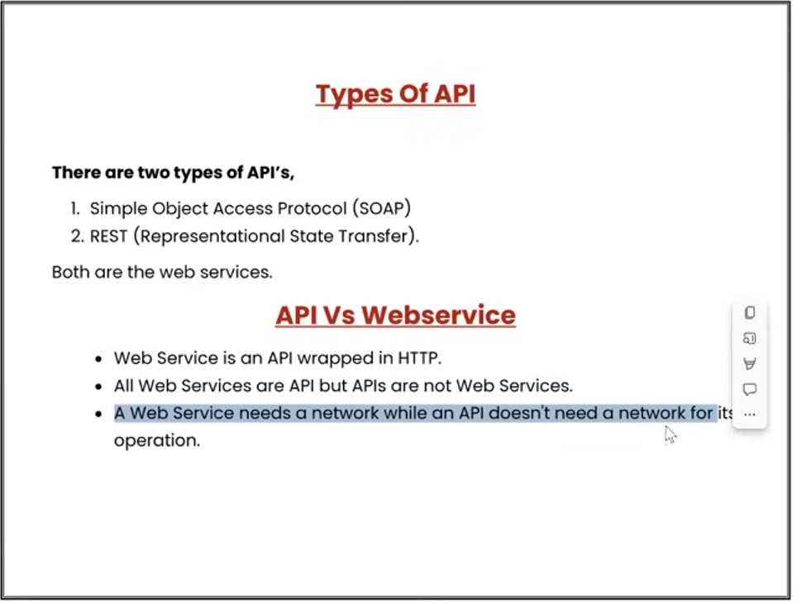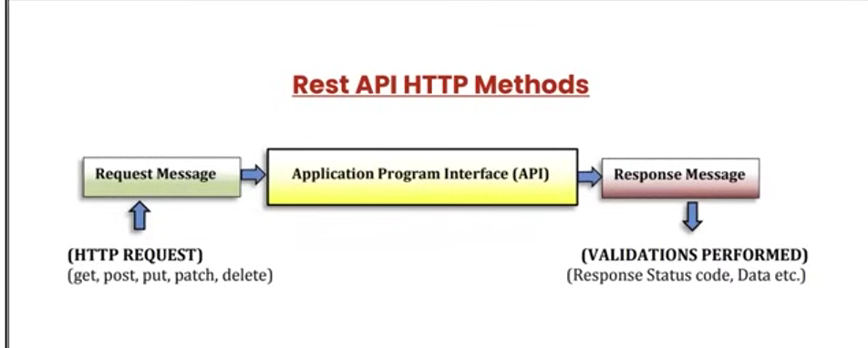
Rest API methods / http requests:
Get : we are getting some response from the server by sending us a request.
Post : sending the data sending the data to the server.
Put : we can update the data in the database server through put request.
delete: we can delete the data from the database.

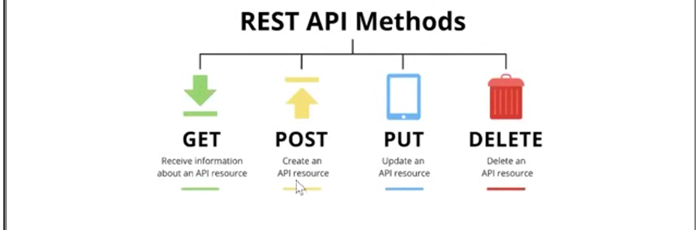
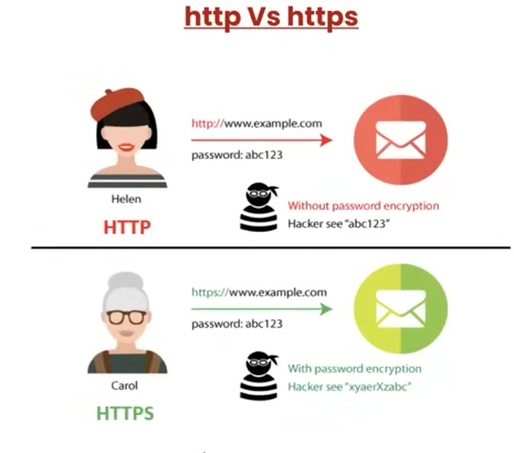
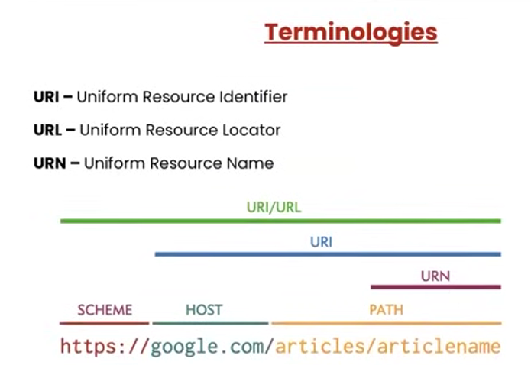
Think of it like this:
- URI = umbrella term (identifier of any kind)
- URL = “locator” (where to find it)
- URN = “name” (what it’s called, independent of location)
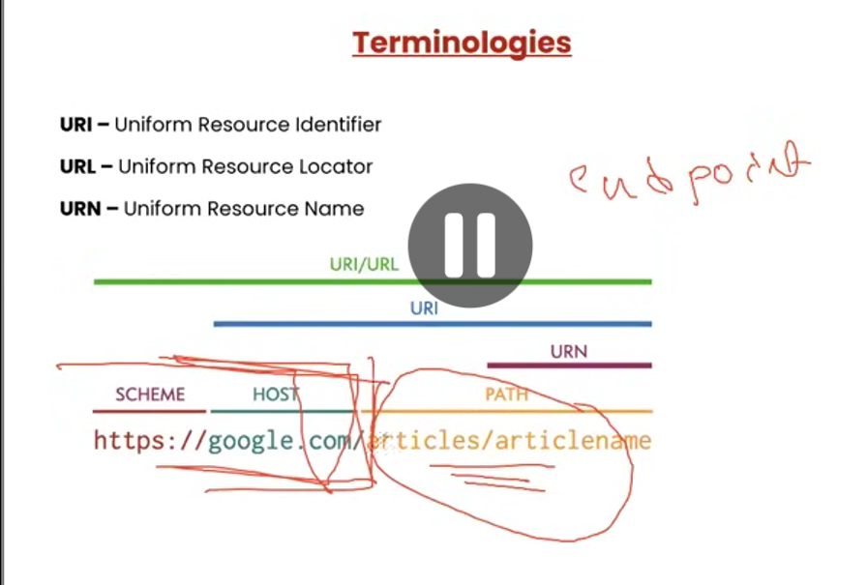
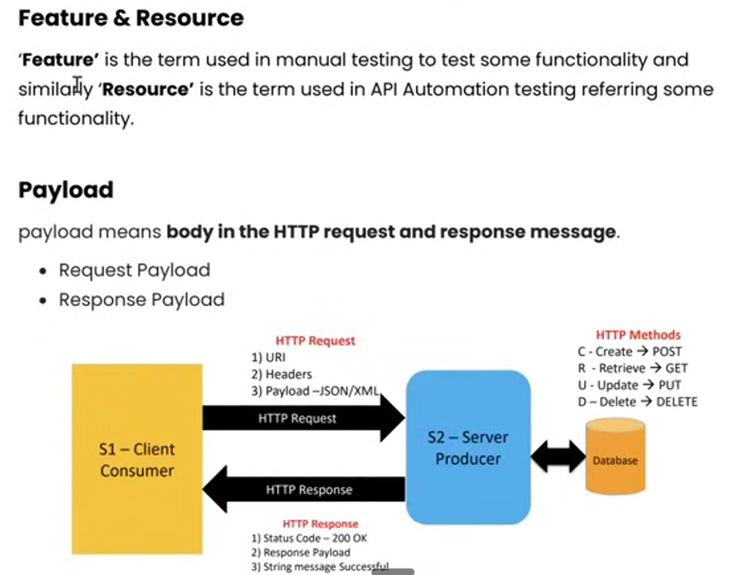
========================-============================-======================-=====

Session 2: API Testing | Postman | Environment Setup & Types of HTTP Requests
Topics Covered: ------------------------- 1) Postman Introduction 2) Postman installation 3) Creating Workspace 4) Creating Collection 5) Creating Requests - Get, Post, Put & Delete 6) Saving & Editing Requests 7) Operations on Collections 8) Things to be validated in response 9) Status codes 10)Cookies & Headers 11) Response body 12) Exporting & Importing Collections

